**Ideation Phase**

**Brainstorm & Idea Prioritization Template**

|  |  |
| --- | --- |
| Date | 27 June 2025 |
| Team ID | LTVIP2025TMID34066 |
| Project Name | SmartSDLC – AI-Enhanced Software Development Lifecycle |
| Maximum Marks | 4 Marks |

**Brainstorm & Idea Prioritization Template:**

In our SmartSDLC brainstorming session, we aim to foster an open and creative environment where every idea is welcomed—no matter how unconventional. Team members are encouraged to think freely about how generative AI can improve the software development lifecycle, from bug fixing to test case generation. We'll prioritize quantity over perfection, build on each other’s inputs, and later cluster ideas based on feasibility and impact. This collaborative approach will help us identify the most innovative and practical features for a smarter, more efficient development assistant.

**Step-1: Team Gathering, Collaboration and Select the Problem Statement**

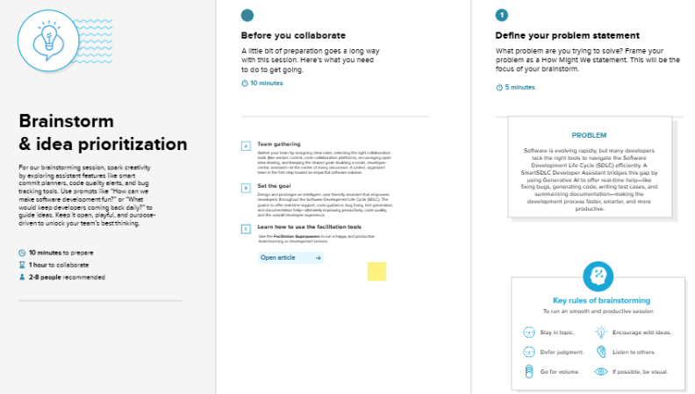

**Step-2: Brainstorm, Idea Listing and Grouping**

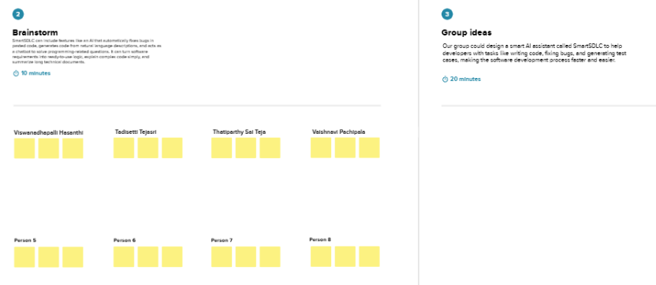

**Step-3: Idea Prioritization**

